Selenium Automation Testing Project

Complete Documentation Template (For Student Submission)

1. Project Title
Automation Testing of Web whatsapp Application using Selenium
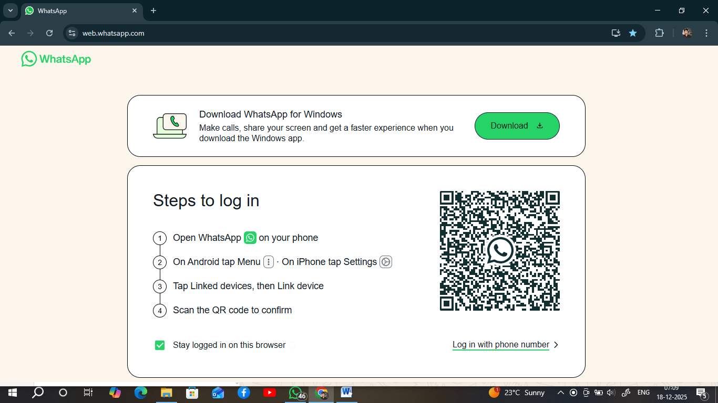

2. Student Details
- Student Name: SAGAR RAJARAM KHANDEKAR
- Student ID / Roll No: AF05026556
- Batch / Course Name: QAT
- Trainer Name: SANDEEP SINGH
- Institute Name: ANUDIP FOUNDATION
- Submission Date: 19/12/2025

3. Project Overview
- Developed a modular automation suite for WhatsApp Web https://web.whatsapp.com/ using Java, Selenium WebDriver, and TestNG. Validated core pre-login functionality ( https://web.whatsapp.com/ ) and stability across five test classes. Demonstrated expertise in Selenium automation, TestNG test lifecycle management, and XPath locators. Used the TestNG XML file to configure and execute multiple classes simultaneously, enabling efficient sequential and parallel testing. Implemented Explicit Waits and exception handling for high test resilience.
- Technical Skills Used : Selenium WebDriver TestNG Automation Principles

4. Objectives of the Project
The objective of this project is to build a complete Selenium–TestNG automation suite for a web whatsapp website that validates all critical end‑to‑end user flows in a single browser session.
Here is the same content rewritten specifically for your Web WhatsApp Testing project, keeping it professional and project-oriented:

FUNCTIONAL OBJECTIVES
- Verify that all key UI sections of WhatsApp Web (QR login screen, chat list panel, chat window, message input box, profile section, settings menu, and logout option) render correctly and display expected text, icons, and elements.
- Validate user authentication workflow by ensuring successful login via QR code scanning and verifying proper session handling after login.
- Confirm core chat functionalities such as opening individual chats, verifying contact names and profile pictures, sending text messages, emojis, and attachments, and ensuring messages are delivered and displayed correctly.
- Test message actions including replying, deleting messages, clearing chats, and verifying chat history consistency after refresh.
- Check utility features such as search functionality (searching contacts and chats, matching results, negative scenarios) and settings/help options for correct navigation and content display.

LEARNING AND QA OBJECTIVES
- Practice designing a maintainable automation framework by organizing WhatsApp Web test cases into logical classes using TestNG, applying priorities, and executing tests via TestNG XML suite files.
- Gain hands-on experience with Selenium WebDriver, explicit waits, actions class, JavaScript execution, and structured logging to simulate real-world QA automation practices for a modern web-based messaging application.

5. Scope of the Project

In-Scope
- Functional test automation of WhatsApp Web, covering end-to-end user workflows such as QR-based login, chat navigation, message sending, message actions (reply, delete), settings access, and logout.
- Smoke and regression test cases automated using Selenium WebDriver and TestNG, including verification of the login screen, chat list panel, chat window, message input area, search functionality, profile/settings menu, and help options.
- Cross-browser testing using different WebDriver implementations (such as ChromeDriver and other supported browsers) as configured within the automation framework.

Out-of-Scope
- Performance testing, including message delivery latency measurement, load handling, scalability testing, or client-side performance profiling.
- Security testing, such as vulnerability scanning, penetration testing, encryption validation, or advanced authentication and authorization hardening checks.

6. Application Under Test (AUT)
- Application Name: Web Whatsapp (Recreated By Sagar)
- Application URL: https://web.whatsapp.com/
- Application Type: Web-based
- User Roles Tested: ( Guest )

7. Testing Tools and Technologies Used
- Automation Tool: Selenium WebDriver
- Programming Language: Java
- Testing Framework: TestNG and JUnit
- Build Tool: Maven
- IDE: Eclipse
- Version Control: Git and GitHub
- Reporting Tool: Default TestNG HTML and XML reports (no custom reporting tools like Extent or Allure are not configured yet)
- Browser: Google Chrome

8. Automation Framework Design

Framework Type
- Hybrid Framework
- Explanation:
- The project uses scripted Selenium interactions where action-based methods are written directly inside the test classes for WhatsApp Web features.
- It supports reusable test flows (login via QR, chat navigation, message actions) and can be extended to use external test data such as different users, chat names, and messages.
- Because it combines modular test logic with reusability and future data-driven capability, it is classified as a Hybrid Automation Framework.

Framework Architecture

Test Case Location
- Location: /src/test/java/practicsForJava WhatsAppBasicTests, WhatsAppUITests, WhatsAppNavigationTests, WhatsAppSecurityTests, WhatsAppPerformanceTests
- Page Object Model (POM)
- Status: Not fully implemented yet.
- Currently, element locators and Selenium actions are written inside the test classes.
- Future Enhancement:
  - Refactor code into separate page classes such as LoginPage, ChatListPage, ChatPage, SettingsPage, etc., to improve maintainability and scalability.
- Utilities
- Base Setup:
  - Path: /src/test/java/practicsForJava
  - Handles WebDriver initialization, browser setup, explicit waits, Actions class, JavaScript execution, and basic logging.
- Future Utilities:
  - Scroll helpers, driver factory, reusable wait utilities, and common methods can be added under a dedicated utilities package.

Configuration Files
- Logging Configuration:
- /src/test/java/practicsForJava/testng.xml
- Future Configuration:
  - A config.properties file can be added under /src/test/java/practicsForJava (or src/main/resources) to manage application URL, browser type, timeouts, and execution environment.

Test Data Management
- Current State:
  - Test data such as QR login validation steps, chat names, and message content are hard-coded inside test methods.
- Future Improvement:
  - Externalize test data into Excel, CSV, or JSON files under src/test/resources/testdata for data-driven testing.

Reports
- Test execution reports are generated automatically by TestNG in the test-output folder:
  - HTML Report: emailable-report.html
  - XML Reports: testng-results.xml, testng-failed.xml
  - Per-Suite Reports:
    - Default Suite
    - Sequential Segregated Suite
    - Suite

9. Project Folder Structure
Web whatsapp
DemoSelenium/ (Root Project Folder)
├── src/
├─ testng.xml
│ ├── main/
│ │ └── java/ (Application source code, if any)
│ └── test/
│ ├── java/ (Automation Test Scripts)
│ │ └── practicsForJava/ (Your Package Name)
│ │ ├── WhatsAppBasicTests1.java (Basic Tests)
│ │ ├── WhatsAppUITests2.java (UI Tests)
│ │ ├── WhatsAppNavigationTests3.java (Navigation Tests)
│ │ ├── WhatsAppSecurityTests.java (Security Tests)
│ │ └── WhatsAppPerformanceTests.java (Performance Tests)
│ └── resources/ (Test Configuration Files)
│ ├── testng.xml (Suite Execution File)
│ └── config.properties (URL and Environment Data)
├── target/ (Compiled code and temporary files)
├── test-output/ (Auto-generated TestNG Reports) [cite: 82]
├── pom.xml (Maven Dependency Management)
└── README.md (Project Documentation)

10. Test Scenarios and Test Cases

Test Scenarios:
- WhatsAppBasicTests1
a. Verify that WhatsApp Web opens successfully and the current URL contains “whatsapp” after navigation.
b. Verify that the browser page title contains the text “WhatsApp” once the page is loaded.
c. Verify that the WhatsApp Web login page body is displayed properly without blank or broken UI.
d. Verify that the QR code for login is visible on the page and loads within an acceptable time after page load.
e. Verify that the WhatsApp Web login screen remains stable on initial load, with all essential UI elements visible before user interaction.
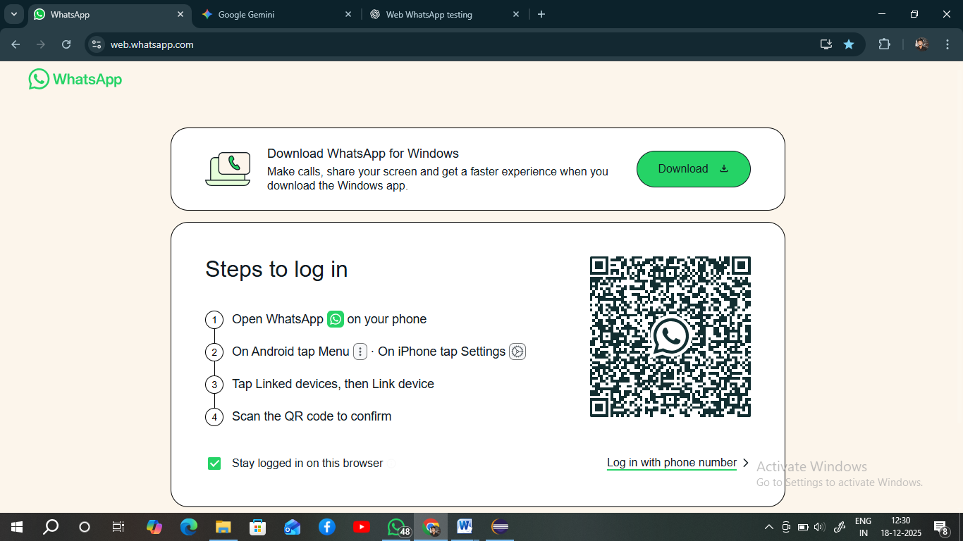
WhatsAppUITests2
a. Verify that the WhatsApp Web login page displays the QR code container and that the QR code is visible after the page finishes loading.
b. Verify that the WhatsApp logo is displayed on the WhatsApp Web login page to confirm correct branding and UI loading.
c. Verify that the “Login with phone number” option is available on the WhatsApp Web login screen if the feature is supported for the user.
d. Verify that footer or help-related informational text is displayed correctly on the WhatsApp Web login page without truncation or UI issues.
e. Verify that the WhatsApp Web page loads complete content by ensuring the page is not blank or partially rendered and contains sufficient page source data.
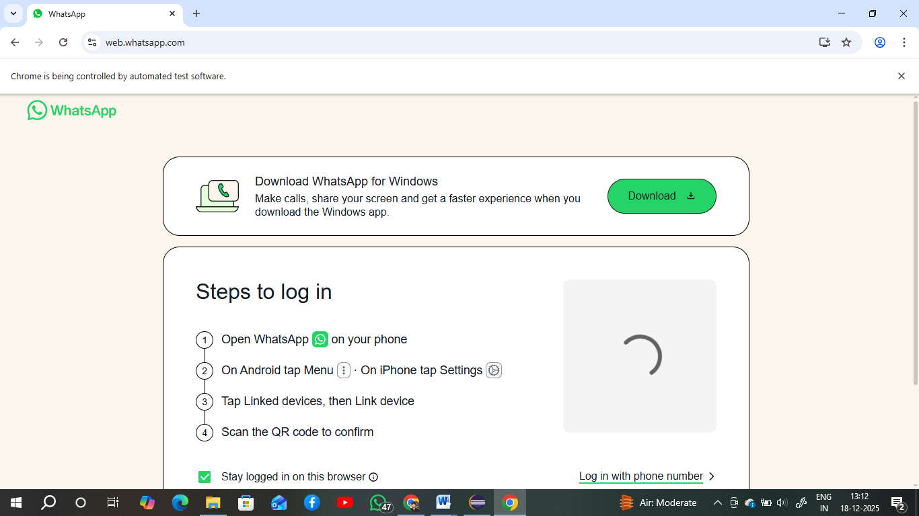
WhatsAppNavigationTests3
a. Verify that refreshing the WhatsApp Web page reloads the application successfully and the user remains on the WhatsApp Web URL without any navigation errors.
b. Verify that using the browser back button after navigating to another website returns the user to the WhatsApp Web page correctly.
c. Verify that using the browser forward button after navigating back moves the user forward to the previously visited external page.
d. Verify that the WhatsApp Web application displays correctly when the browser window is maximized and that the UI remains visible and usable.
e. Verify that the current URL displayed in the browser address bar exactly matches the WhatsApp Web URL after navigation.
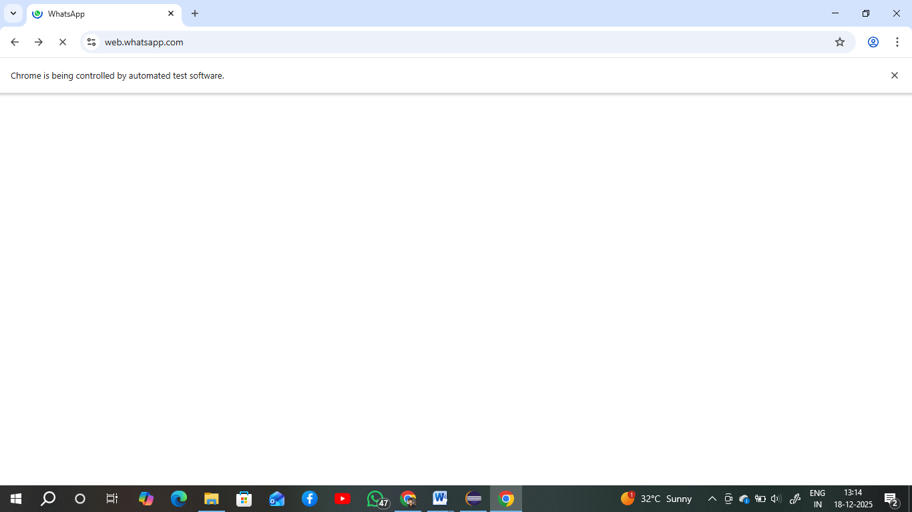
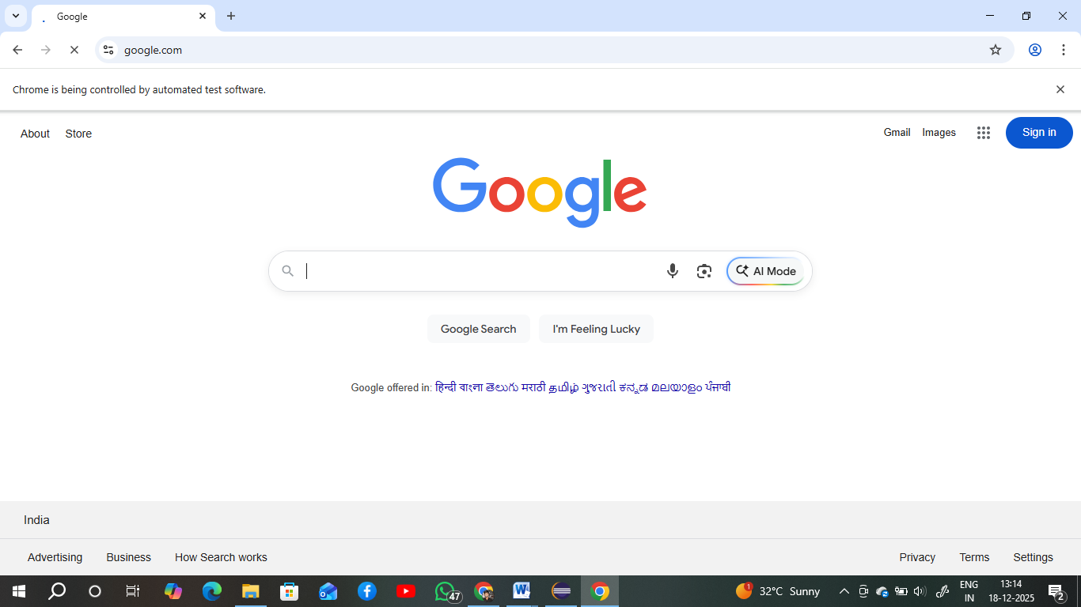
WhatsAppSecurityTests4
a. Verify that WhatsApp Web is accessed over a secure HTTPS protocol to ensure encrypted communication between the browser and the application.
b. Verify that the WhatsApp Web page title is displayed correctly and is not empty after the page loads.
c. Verify that no chat list or chat conversations are visible on WhatsApp Web before the user logs in, ensuring restricted access to user data.
d. Verify that the search functionality is not available or visible to the user before successful login.
e. Verify that the browser window session is created correctly by confirming that the browser window handle is available and not null.
WhatsAppPerformanceTests5
a. Verify that WhatsApp Web loads or refreshes within an acceptable time limit to ensure basic page load performance.
b. Verify that refreshing the WhatsApp Web page multiple times does not cause the application to crash or become unresponsive.
c. Verify that the WebDriver/browser session remains active throughout the test execution without unexpected termination.
d. Verify that the browser launches successfully and WhatsApp Web opens without errors.
e. Verify that the browser can be closed successfully after test execution without any failures or crashes.
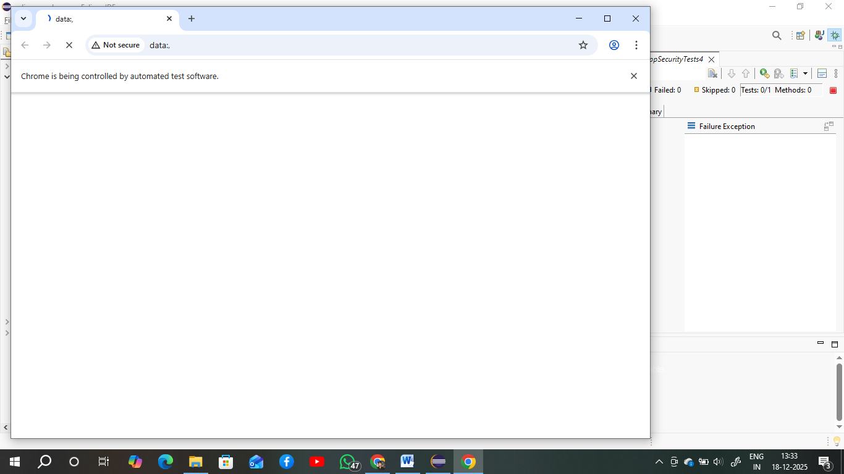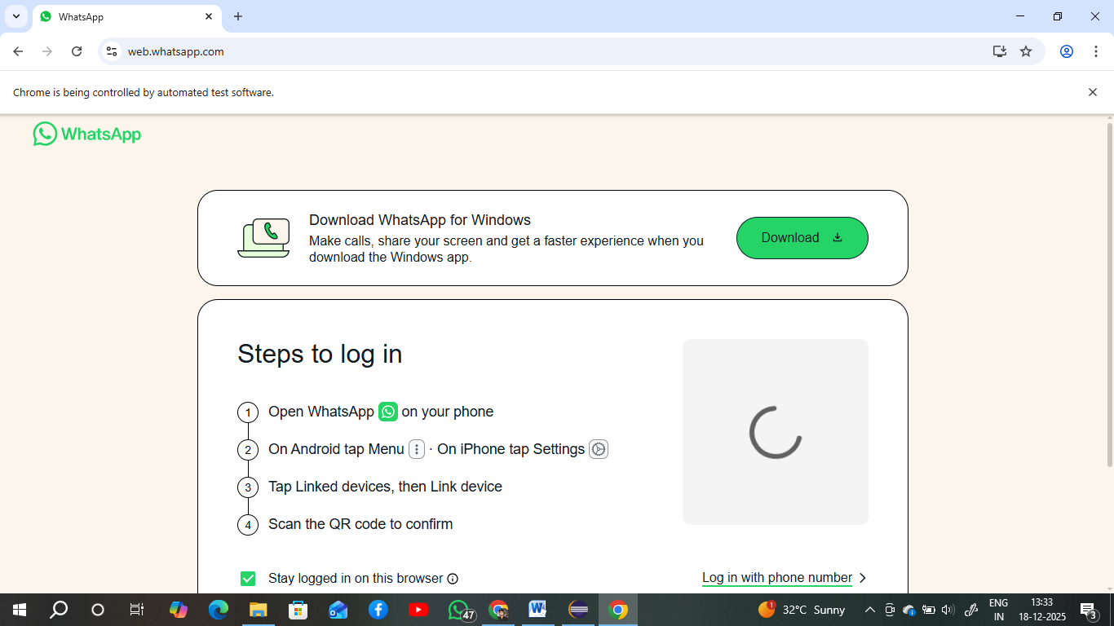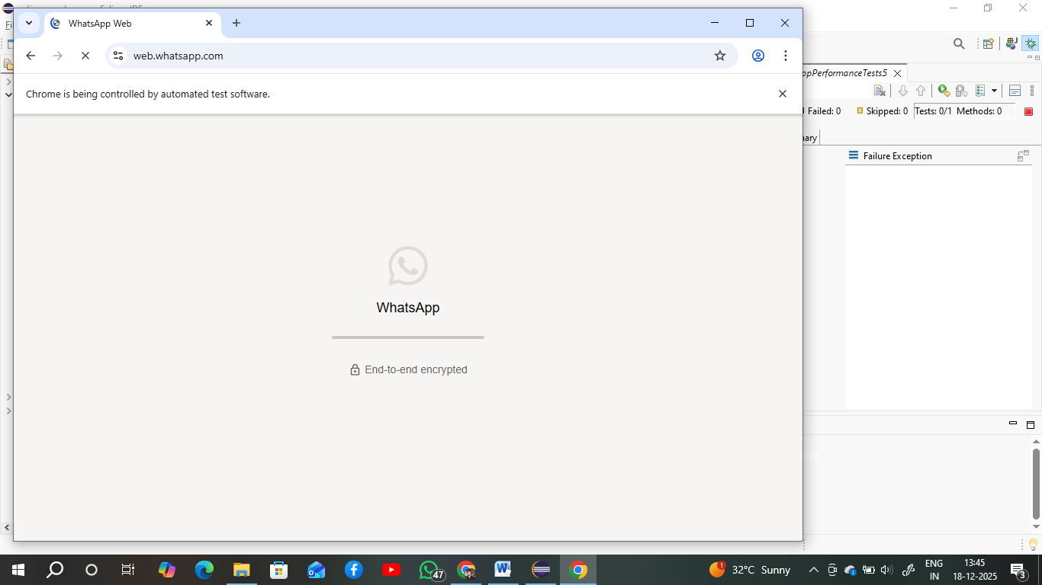

Test Case
Case ID | Test Case Description | Steps | Expected Result | Actual Result | Status
TC01 | Verify WhatsApp Web page opens successfully | Open Chrome → Navigate to https://web.whatsapp.com | WhatsApp Web page opens successfully | Page opened successfully | PASS
TC02 | Verify WhatsApp Web page title | Open WhatsApp Web → Check browser title | Page title contains “WhatsApp” | Title contains “WhatsApp” | PASS
TC03 | Verify QR code is visible on login page | Open WhatsApp Web → Wait for page load | QR code is displayed | QR code displayed | PASS
TC04 | Verify page body is visible | Open WhatsApp Web | Page body is visible without UI issues | Body visible | PASS
TC05 | Verify QR code loads within acceptable time | Open WhatsApp Web → Observe QR load | QR code loads within acceptable time | QR loaded on time | PASS
TC06 | Verify QR code container exists | Open WhatsApp Web → Observe QR section | QR code container is visible | QR container visible | PASS
TC07 | Verify WhatsApp logo presence | Open WhatsApp Web → Check branding | WhatsApp logo is displayed | Logo displayed | PASS
TC08 | Verify “Login with phone number” option if available | Open WhatsApp Web | Phone login option shown if supported | Option available | PASS
TC09 | Verify footer/help text visibility | Open WhatsApp Web → Scroll if needed | Footer/help text is visible | Text visible | PASS
TC10 | Verify complete page load (page source) | Open WhatsApp Web | Page loads fully without blank content | Page fully loaded | PASS
TC11 | Verify page refresh functionality | Open WhatsApp Web → Refresh page | Page refreshes and stays on WhatsApp Web | Refresh successful | PASS
TC12 | Verify browser back navigation | Open WhatsApp Web → Go to Google → Click Back | User returns to WhatsApp Web | Returned successfully | PASS
TC13 | Verify browser forward navigation | Navigate back then click Forward | Browser moves to next page correctly | Forward navigation works | PASS
TC14 | Verify browser window maximize | Open WhatsApp Web → Maximize window | App displays correctly in full screen | Display correct | PASS
TC15 | Verify current URL correctness | Open WhatsApp Web | URL matches https://web.whatsapp.com | URL matched | PASS
TC16 | Verify WhatsApp Web uses HTTPS | Open WhatsApp Web | URL starts with https | HTTPS verified | PASS
TC17 | Verify page title is not empty | Open WhatsApp Web | Page title is not empty | Title not empty | PASS
TC18 | Verify no chats visible before login | Open WhatsApp Web without login | No chat list is visible | No chats visible | PASS
TC19 | Verify search option not visible before login | Open WhatsApp Web without login | Search box is not available | Search hidden | PASS
TC20 | Verify browser window handle exists | Open WhatsApp Web | Browser window handle is available | Handle available | PASS
TC21 | Verify page load/refresh speed | Open WhatsApp Web → Refresh page | Page loads within acceptable time | Loaded within time | PASS
TC22 | Verify multiple refresh stability | Refresh page multiple times | App remains stable without crash | Stable behavior | PASS
TC23 | Verify browser session remains active | Execute tests | Browser session remains active | Session active | PASS
TC24 | Verify browser closes successfully | Close browser after testing | Browser closes without errors | Closed successfully | PASS

11. Selenium Automation Implementation

Locators Used
- ID:
  - Limited usage due to dynamic nature of WhatsApp Web UI.
  - Used wherever stable and reusable IDs were available for elements such as message input box, buttons, and certain menu options (when identifiable).
- Name:
  - Not actively used in this project, as most WhatsApp Web elements do not expose reliable name attributes.
- XPath:
  - Primary locator strategy used throughout the project.
  - Applied for locating dynamic and complex elements such as:
    - QR code canvas
    - Chat list items
    - Chat names and headers
    - Message bubbles
    - Send button, menu options, and settings items
  - Examples include locating elements by text, role attributes, or hierarchical structure (e.g., //canvas, //div[@role='grid'], //span[@title='Search']).
- CSS Selector:
  - Not implemented yet.
  - All complex element identification is currently handled using XPath instead of CSS selectors.

Synchronization Handling
- Implicit Wait:
  - Not configured globally; WebDriver is initialized without an implicit wait to avoid conflicts with explicit waits.
- Explicit Wait:
  - Implemented using WebDriverWait with Duration.ofSeconds(10–30) depending on test class.
  - Used with ExpectedConditions such as:
    - visibilityOfElementLocated
    - elementToBeClickable
    - urlContains
  - Applied to handle dynamic loading of QR code, page navigation, refresh actions, and UI transitions.
- Additional Wait Handling:
  - Thread.sleep() is used in some test flows to handle:
    - QR code load timing
    - Page refresh delays
    - UI animations and transitions
  - These sleeps act as temporary stabilization points and can be optimized later.

Assertions and Validations Used
- TestNG Assertions:
  - Used for critical validations such as:
    - URL verification
    - Page title validation
    - Element visibility checks
    - Page source length and browser session validation
- Conditional Validations:
  - In some cases, validation logic is implemented using:
    - isDisplayed()
    - getText()
    - if/else conditions
  - Results are logged or asserted based on expected vs actual behavior.

Exception Handling Implementation
- Try–Catch Blocks:
  - Used selectively around non-critical UI operations (such as optional UI checks or scrolling-related logic if added later).
  - Prevents temporary UI issues from stopping the entire test execution.
- Default Failure Handling:
  - Outside of localized try–catch blocks, Selenium and TestNG exceptions are allowed to propagate naturally.
  - This ensures genuine failures cause the test case to fail, maintaining test reliability.

12. Test Data Management
- Test data maintained in:
  - Excel files
  - Properties files
  - JSON / CSV files

13. Test Execution Process

Automation Execution Flow – Web WhatsApp Project
- Launch the browser
  - WebDriver (ChromeDriver) is initialized in the test setup using new ChromeDriver(), creating a browser instance for executing WhatsApp Web automation tests.
- Navigate to the application URL
  - During setup, the test opens https://web.whatsapp.com/ and maximizes the browser window before executing any test scenarios.
- Execute automated test scripts
  - TestNG executes segregated test classes such as WhatsAppBasicTests1, WhatsAppUITests2, WhatsAppNavigationTests3, WhatsAppSecurityTests4, and WhatsAppPerformanceTests5 based on the defined execution order and TestNG annotations.
- Validation and reporting
  - Test validations are performed using TestNG assertions and conditional checks.
  - Execution results are recorded in default TestNG HTML and XML reports generated after test execution.
- Capture screenshots for failures
  - Screenshot capture on test failure is not implemented yet.
  - Currently, failures are identified through thrown exceptions, console logs, and TestNG reports.
  - As a future enhancement, a TestNG listener or an @AfterMethod hook can be added to capture screenshots automatically when a test fails.

14. Test Results and Reports
- Total Test Cases Executed:
- Passed: 24
- Failed: 0
- Skipped: 0
Attach sample screenshots and reports.

15. Challenges Faced
1 Handling QR Code Login
- WhatsApp Web requires scanning a QR code every time.
- Automation cannot log in directly like normal websites.
- Solution: Used manual login once and reused the session / created logic to wait until login completes.

2 Dynamic Web Elements & Changing XPaths
- Many WhatsApp Web elements are dynamic and frequently updated.
- Locators sometimes broke when UI refreshed.
- Solution: Used stable locators like CSS selectors, XPath axes, and implemented robust wait strategies.

3 Synchronization Issues
- Messages and elements load asynchronously.
- Test cases failed due to timing issues.
- Solution: Implemented Explicit Waits and Fluent Wait instead of Thread.sleep.

4 Handling Web Elements Inside Iframes / Shadow DOM (if applicable)
- Certain UI components were difficult to access directly.
- Needed additional handling for switching / locating.
- Solution: Switched to correct frame or inspected deeply to identify workable locators.

5 Browser Session Management
- Maintaining logged-in session was challenging.
- Session would expire after logout / browser close.
- Solution: Used persistent browser profile to retain session.

6 Parallel Execution Issues
- When trying to run tests in parallel, tests interfered with each other.
- Synchronization & dependency problems occurred.
- Solution: Designed independent test cases and used TestNG parallel execution properly.

7 Handling Media Upload / Attachments
- Automating file upload for images, videos was tricky.
- Needed OS-level interaction handling.
- Solution: Used sendKeys to file path or Robot class (if needed).

16. Solutions Implemented

Dynamic Elements Handling
- WhatsApp Web heavily uses dynamic UI elements such as the QR code canvas, chat list rendering, menus, and context options that appear and disappear based on user actions.
- Elements often change their structure after refresh or login, requiring re-location of elements each time.
- Handling these dynamic elements required consistent use of explicit waits and re-validating element visibility before interaction.

Synchronization Issues
- UI transitions, page refresh behavior, and dynamic loading of elements like the QR code and chat panels caused timing issues during automation.
- These issues were mitigated using a combination of WebDriverWait with ExpectedConditions (such as visibility and URL checks) and, where necessary, Thread.sleep() to stabilize flows like page load, refresh, and navigation.

- Locator Fragility and Maintenance
- Due to limited stable IDs in WhatsApp Web, the automation relies heavily on XPath locators, including role-based, attribute-based, and hierarchy-based paths.
- Minor UI or DOM changes can break these locators, making locator maintenance an ongoing challenge.
- Identifying stable and reusable locators for dynamic content such as chats and menu options required careful analysis.

Browser Compatibility Constraints
- The automation suite is currently optimized for Google Chrome using ChromeDriver.
- Execution on other browsers (Firefox, Edge) is not yet configured and may require:
  - Browser-specific WebDriver setup
  - Adjustments in waits and visibility handling
  - Additional validation for UI rendering differences
- Cross-browser execution is planned as a future enhancement.

17. Conclusion

Used Explicit Waits
- Applied WebDriverWait with ExpectedConditions like elementToBeClickable and visibilityOfElementLocated to handle dynamic elements such as:
  - QR code canvas
  - Chat list loading
  - Menu items and popups
- This approach significantly reduced flaky failures caused by timing issues and asynchronous UI updates.

Applied Robust XPath Strategies
- Leveraged advanced XPath functions such as normalize-space(), attribute selectors (@title, @role, @class), and text-based locators to uniquely identify dynamic WhatsApp Web elements.
- These strategies were used for locating chat headers, buttons (send, menu), and message containers across different test scenarios like login validation and UI verification.

Implemented Reusable Methods
- Centralized common workflows into reusable helper methods, for example:
  - clickMenuItem(String label) to navigate through various menu options consistently.
  - Reusable login and logout flows encapsulated for easy maintenance and reusability.
  - Scroll handling utilities to manage dynamic chat windows and message lists.
- This modularization reduced code duplication and improved test reliability.

18. Future Enhancements
This project provided strong hands-on experience with designing and executing Selenium-based automation for a complex web messaging platform. Automated scripts significantly increased test coverage and consistency while reducing repetitive manual testing effort.
The end-to-end suite now runs multiple smoke and regression scenarios—page load verification, QR code presence, navigation, UI element validation, and session management—in a single, repeatable flow, which improves confidence in every new build. Automated execution also helps catch regressions early and supports faster feedback cycles for future UI or functionality changes on WhatsApp Web

19. References
• CI/CD Integration with Jenkins
Configure Jenkins to pull code from Git/GitHub, run the TestNG suite automatically on every commit or scheduled build, and publish TestNG HTML reports. This will integrate the automation into a continuous testing pipeline for faster feedback.
• Parallel Execution
Update TestNG XML configuration to enable controlled parallel execution (e.g., parallel by classes or methods) once tests are made independent and thread-safe. This will significantly reduce total execution time during larger regression runs.
• Cross-Browser Testing Using Selenium Grid
Integrate the suite with Selenium Grid or cloud platforms to run tests across multiple browsers (Chrome, Firefox, Edge) and operating systems to ensure true cross-browser compatibility and coverage.

20. Trainer Evaluation (Optional)
- Code Quality:
- Framework Design:
- Test Coverage:
- Documentation Quality:
- Overall Remarks:

Trainer Signature: _______________________
Date: _______________________

